Topical Red Palm Oil Modulates Cutaneous Oxidative-Stress Biomarkers in Streptozotocin-Induced Diabetic Wistar Rats
Abstract
Diabetes-associated oxidative stress contributes to cutaneous injury, but the local antioxidant effect of red palm oil (RPO) has not been well characterized. This study evaluated the effect of 10% topical RPO on superoxide dismutase (SOD) activity and malondialdehyde (MDA) levels in diabetic Wistar rat skin. In this controlled post-test-only experiment, 27 male Wistar rats were allocated to non-diabetic control, diabetic control, and diabetic plus 10% RPO groups (n=9/group). Diabetes was induced by a single intraperitoneal streptozotocin injection (50 mg/kg) and confirmed by tail-vein blood glucose >200 mg/dL. RPO or base cream was applied to a 3 x 3 cm dorsal area twice daily for 28 days. Full-thickness dorsal skin samples were collected on day 29 for colorimetric SOD and MDA measurement. SOD was analyzed using one-way ANOVA with Tukey testing, and MDA using the Kruskal-Wallis test with Holm-adjusted pairwise Mann-Whitney U tests. SOD activity differed among groups (F=23.696, p<0.001): 42.35 ± 1.99 U/mL in non-diabetic controls, 32.92 ± 4.33 U/mL in diabetic controls, and 39.88 ± 2.13 U/mL in the RPO group. MDA also differed among groups (H=16.358, p<0.001), with mean values of 5.45 ± 1.19, 10.24 ± 2.00, and 7.59 ± 2.02 nmol/mL, respectively. SOD and MDA were negatively correlated (r=-0.544, p=0.003). Topical 10% RPO improved the antioxidant-oxidant biomarker profile in diabetic rat skin; its therapeutic relevance requires further formulation and translational studies.
Keywords: Cutaneous Oxidative Stress; Diabetes Mellitus; Malondialdehyde; Red Palm Oil; Superoxide Dismutase
Introduction
Diabetes mellitus is a major and growing global health problem. Beyond persistent hyperglycemia, diabetes is associated with microvascular and metabolic disturbances that can impair skin integrity and contribute to serious complications, including diabetic foot ulcers. ^{1,2}
Oxidative stress is one of the biological processes linking diabetes to tissue injury. Chronic hyperglycemia and mitochondrial dysfunction can increase the production of reactive oxygen species (ROS), while sustained ROS exposure may prolong inflammation, reduce cell proliferation, and interfere with tissue repair. ^{3,4} In cutaneous tissue, superoxide dismutase (SOD) is a key enzymatic component of antioxidant defense, whereas malondialdehyde (MDA) reflects lipid peroxidation and oxidative membrane injury. ⁵
Topical antioxidant interventions have shown the potential to modify oxidative conditions in diabetic skin models. Chrysin and topical metformin have been reported to improve antioxidant markers and reduce lipid-peroxidation-related outcomes in diabetic wound models, while topical Phaleria macrocarpa extract improved inflammatory and proliferative phases in diabetic rats. ⁶⁻⁸ However, the local effect of red palm oil (RPO) on biochemical markers of oxidative stress in diabetic skin remains insufficiently defined.
RPO derived from Elaeis guineensis contains lipophilic compounds, including carotenoids, tocopherols, tocotrienols, polyphenols, phytosterols, squalene, and coenzyme Q10, that may be relevant to cutaneous antioxidant protection and barrier support. ^{9,10} Previous experimental studies have reported antioxidant and anti-inflammatory effects of RPO in non-cutaneous models, including increases in antioxidant enzyme activity and reductions in MDA. ^{11,12} In addition, topical or palm-derived tocotrienol and vitamin E preparations have shown wound-repair or antioxidant-related activity in experimental models. ¹³⁻¹⁸ These findings provide a rationale for examining RPO as a topical preparation in diabetic skin.
This study evaluated the effect of topical 10% RPO on cutaneous SOD activity and MDA levels in streptozotocin-induced diabetic Wistar rats.
Materials and Methods
Study design
A controlled laboratory experiment with a post-test-only control-group design was conducted. The study included three parallel groups: a non-diabetic control group (ND), a diabetic control group (DM), and a diabetic group treated with 10% topical RPO (DM+RPO). Each group included nine animals, for a total of 27 rats.
Animals and ethical approval
Male Wistar rats aged 8-12 weeks and weighing 150-200 g were housed under standard laboratory conditions with a 12-h light/dark cycle at 22 ± 3 °C and free access to food and water. Animals were acclimatized before the intervention. The study protocol was reviewed and approved by an institutional health research ethics committee before study initiation. To preserve double-blind peer review, the committee name and approval reference are provided only in the unblinded title-page file.
Diabetes induction and experimental groups
Rats were fasted for 12 h before diabetes induction. Diabetes was induced by a single intraperitoneal injection of streptozotocin (STZ; 50 mg/kg body weight) dissolved in 0.1 M citrate buffer (pH 4.5). Five days after injection, tail-vein blood glucose was measured. Rats with blood glucose levels >200 mg/dL were classified as diabetic. The ND group did not receive STZ and was treated with base cream. The DM group received STZ and base cream. The DM+RPO group received STZ and 10% topical RPO.
Topical RPO intervention
The red palm oil component used for the topical preparation was red palm stearin, the stearin fraction of red palm oil. Dorsal hair was carefully shaved before application. The 10% RPO preparation was applied to a 3 × 3 cm dorsal skin area twice daily for 28 consecutive days. The ND and DM groups received base cream at the same frequency and for the same duration.
Tissue collection and biochemical measurements
On day 29, rats were anesthetized in accordance with the approved laboratory protocol, and full-thickness dorsal skin tissue was excised from the treatment area. SOD activity and MDA levels were determined using colorimetric methods. SOD activity was expressed as U/mL and MDA as nmol/mL. Total tissue protein was also measured using the Bradford method to support biochemical sample interpretation and quality control.
Statistical analysis
Normality was assessed using the Shapiro-Wilk test and variance homogeneity using Levene's test. SOD data were analyzed using one-way analysis of variance (ANOVA), followed by Tukey post hoc testing. MDA data were analyzed using the Kruskal-Wallis test, followed by pairwise Mann-Whitney U testing with Holm correction. The association between SOD activity and MDA level was assessed using correlation analysis, and the available statistical output was reported as Pearson's correlation coefficient. All tests were two-sided, and p < 0.05 was considered statistically significant.
Results
The analysis included 27 rats (n=9 per group). Table 1 summarizes the descriptive values for SOD activity and MDA level. The DM group had the lowest mean SOD activity (32.92 ± 4.33 U/mL), whereas the ND and DM+RPO groups had mean values of 42.35 ± 1.99 and 39.88 ± 2.13 U/mL, respectively. In contrast, mean MDA was highest in the DM group (10.24 ± 2.00 nmol/mL), followed by the DM+RPO group (7.59 ± 2.02 nmol/mL) and the ND group (5.45 ± 1.19 nmol/mL).
Table 1. Cutaneous SOD activity and MDA concentration by experimental group.
Outcome | ND (n=9) | DM (n=9) | DM+RPO (n=9)
SOD activity (U/mL) | 42.35 ± 1.99^{b} | 32.92 ± 4.33ª | 39.88 ± 2.13^{b}
MDA concentration (nmol/mL) | 5.45 ± 1.19ª | 10.24 ± 2.00^{c} | 7.59 ± 2.02^{b}
Values are mean ± SD. Different superscript letters within the same row indicate significant pairwise differences (p < 0.05).
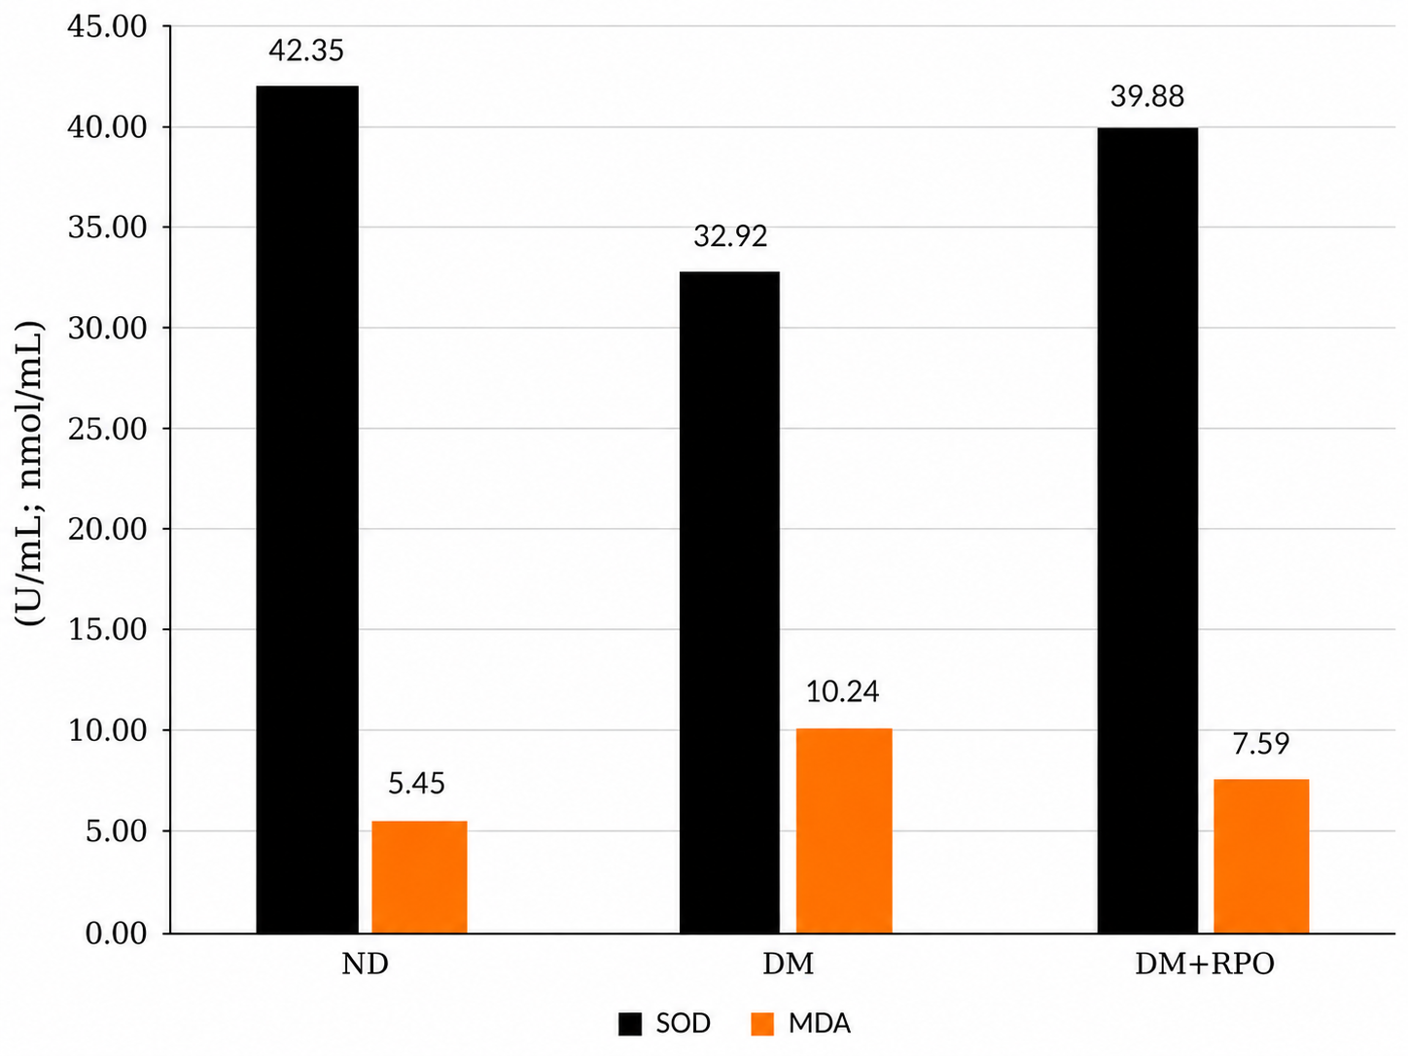
Figure 1. Mean cutaneous SOD activity and MDA concentration by experimental group. ND, non-diabetic control; DM, diabetic control; DM+RPO, diabetic rats receiving 10% topical red palm oil.
SOD data met the assumptions for parametric analysis: Shapiro-Wilk p values were ≥0.082 across groups, and the Levene test was not significant (p=0.053). One-way ANOVA showed a significant overall difference in SOD activity (F=23.696, p<0.001). Tukey testing indicated that SOD activity in the DM group was significantly lower than in the ND and DM+RPO groups, whereas the ND and DM+RPO groups did not differ significantly (Table 2).
MDA data did not meet the normality criterion in the ND (p=0.037) and DM+RPO (p=0.005) groups. The Kruskal-Wallis test demonstrated a significant overall difference in MDA levels (H=16.358, p<0.001). Pairwise Mann-Whitney U tests with Holm correction indicated significant differences among all three groups. Thus, topical RPO reduced MDA compared with diabetic control, although mean MDA remained higher than in non-diabetic control (Table 2).
Table 2. Assumption testing and global between-group comparison of oxidative-stress biomarkers.
Analysis | SOD activity | MDA concentration
Shapiro-Wilk p (ND / DM / DM+RPO) | 0.082 / 0.280 / 0.617 | 0.037 / 0.316 / 0.005
Levene's test p value | 0.053 | 0.332
Global test | One-way ANOVA | Kruskal-Wallis
Test statistic | F = 23.696 | H = 16.358
Global p value | <0.001 | <0.001
ND, non-diabetic control; DM, diabetic control; DM+RPO, diabetic rats receiving 10% topical red palm oil. SOD was followed by Tukey's test. MDA was followed by pairwise Mann-Whitney U tests with Holm correction; all three pairwise comparisons were significant (p < 0.05).
Across all animals, SOD activity was negatively correlated with MDA level (r=-0.544, p=0.003; n=27), indicating that higher antioxidant enzyme activity was associated with lower lipid peroxidation (Table 3).
Table 3. Correlation between cutaneous SOD activity and MDA concentration (n=27).
Statistic | SOD vs MDA
Pearson correlation coefficient (r) | -0.544
p value | 0.003
Number of observations | 27
Discussion
This study found that STZ-induced diabetes was associated with lower cutaneous SOD activity and higher MDA level, whereas topical 10% RPO shifted both markers toward the non-diabetic profile. Compared with diabetic controls, RPO-treated rats had higher SOD activity and lower MDA concentration. The difference in MDA between the RPO-treated and non-diabetic groups remained significant, suggesting a partial rather than complete restoration of the oxidative-stress profile.
The pattern observed in the diabetic control group is biologically consistent with the oxidative burden associated with chronic hyperglycemia. Excess ROS can overwhelm endogenous antioxidant systems, contribute to lipid peroxidation, and disrupt the cellular processes required to maintain skin integrity. ³⁻⁵ Therefore, the lower SOD and higher MDA values in the DM group provide biochemical evidence of impaired redox balance in this experimental diabetic skin model.
The response after RPO treatment is plausible given the composition of RPO. RPO contains carotenoids and vitamin E isomers, including tocopherols and tocotrienols, as well as other lipophilic bioactives that have antioxidant relevance and may be suitable for topical delivery because of their affinity with lipid-rich skin structures. ^{9,10} In non-cutaneous animal models, RPO has been associated with enhanced antioxidant defenses and reduced lipid peroxidation. ^{11,12} Palm-derived tocotrienol, vitamin E, and RPO-related preparations have also shown support for cutaneous repair, keratinocyte-related outcomes, and antioxidant or anti-inflammatory responses in experimental studies. ¹³⁻¹⁸ Although the present study did not measure individual RPO constituents, tissue penetration, or molecular pathways, the increase in SOD and reduction in MDA are compatible with an antioxidant effect in the treated skin.
The present results are directionally consistent with other topical antioxidant approaches evaluated in diabetic wound or skin-injury models. Studies of chrysin, topical metformin, and topical botanical preparations, for example, have reported improved antioxidant status, reduced oxidative damage markers, or improved repair-related phases. ⁶⁻⁸ Other antioxidant or ROS-scavenging topical systems, including sinapic acid-loaded gel and glucose-responsive antioxidant hydrogel, further support the concept that local redox modulation can influence diabetic skin repair biology. ^{19,20} However, this study did not use a wound model and did not assess wound closure, histopathology, collagen deposition, angiogenesis, or inflammatory mediators. Accordingly, the findings should be interpreted as evidence of biochemical modulation in diabetic skin rather than proof of improved wound healing.
The negative correlation between SOD and MDA supports the expected inverse relationship between antioxidant defense and lipid peroxidation. Nevertheless, this correlation was calculated across all experimental groups and cannot establish a direct causal relationship. It may also reflect the overall contrast between non-diabetic, diabetic, and RPO-treated animals. Future studies should examine within-group relationships and include mechanistic endpoints ²¹⁻²⁴, such as Nrf2-related signaling, inflammatory cytokines, apoptosis-related markers, angiogenesis, oxidative DNA or protein damage, and histopathological remodeling.
Several limitations should be considered. First, this was a small preclinical study using a chemically induced diabetes model. Second, only two oxidative-stress biomarkers were measured, and the RPO formulation was not characterized for active-compound content, stability, or skin penetration. Third, no wound-related outcomes, histopathological measures, inflammatory markers, collagen deposition, or angiogenesis assessments were available. These limitations restrict clinical extrapolation. Dose-response studies, standardized formulation characterization, dermal safety testing, mechanistic assays, and controlled wound-healing experiments are needed before considering clinical evaluation.
Conclusions
Topical 10% RPO increased cutaneous SOD activity and reduced MDA level in STZ-induced diabetic Wistar rats. These findings support further investigation of RPO as a topical antioxidant candidate for diabetic skin. The results do not establish clinical benefit or wound-healing efficacy and should be confirmed through formulation, histological, mechanistic, and translational studies.
Acknowledgements
The authors acknowledge the technical laboratory staff who supported routine animal care and biochemical analysis.
Declaration of generative AI and AI-assisted technologies in the writing process
During the preparation of this work, the authors used ChatGPT (OpenAI) to improve the language. The authors reviewed and edited the output as necessary and accept full responsibility for the content of the final manuscript.
References
- International Diabetes Federation. IDF Diabetes Atlas. 11th ed. Brussels: International Diabetes Federation; 2025.
- McDermott K, Fang M, Boulton AJM, Selvin E, Hicks CW. Etiology, epidemiology, and disparities in the burden of diabetic foot ulcers. Diabetes Care. 2023;46(1):209-21. doi:10.2337/dci22-0043.
- Caturano A, D'Angelo M, Mormone A, Russo V, Mollica MP, Salvatore T, et al. Oxidative stress in type 2 diabetes: Impacts from pathogenesis to lifestyle modifications. Curr Issues Mol Biol. 2023;45(8):6651-66. doi:10.3390/cimb45080420.
- Deng L, Du C, Song P, Chen T, Rui S, Armstrong DG, et al. The role of oxidative stress and antioxidants in diabetic wound healing. Oxid Med Cell Longev. 2021;2021:8852759. doi:10.1155/2021/8852759.
- Shabalala SC, Johnson R, Basson AK, Ziqubu K, Hlengwa N, Mthembu SXH, et al. Detrimental effects of lipid peroxidation in type 2 diabetes: Exploring the neutralizing influence of antioxidants. Antioxidants (Basel). 2022;11(10):2071. doi:10.3390/antiox11102071.
- Liu Y, Wang F, Chen B. Anti-inflammatory and antioxidant effects of chrysin mitigates diabetic foot ulcers. Int J Pharmacol. 2023;19:122-30. doi:10.3923/ijp.2023.122.130.
- Tombulturk FK, Dedeakayogullari Demirci H. Reducing oxidative stress and enhancing antioxidant defenses for faster healing in diabetic wounds: The role of topical metformin. Int J Med Biochem. 2025;8(2):89-98. doi:10.14744/ijmb.2025.15428.
- Sulistyoningrum E, Rosmelia R, Fidiangingsih I, Narantika SG, Cleopatra NN, Azzahra F. Wound healing activity of topical Phaleria macrocarpa extract in type 2 diabetic rats. Universa Medicina. 2024;43(2):136-47. doi:10.18051/UnivMed.2024.v43.136-147.
- Tan CH, Lee CJ, Tan SN, Poon DTS, Chong CYE, Pui LP. Red palm oil: A review on processing, health benefits and its application in food. J Oleo Sci. 2021;70(9):1201-10. doi:10.5650/jos.ess21108.
- Madoromae H, Lertcanawanichakul M. Red palm oil: Nutritional composition, bioactive properties, and potential applications in health and cosmetics: A narrative review. Molecules. 2025;30(22):4402. doi:10.3390/molecules30224402.
- Ajuwon OR, Marnewick JL, Oguntibeju OO, Davids LM. Red palm oil ameliorates oxidative challenge and inflammatory responses associated with lipopolysaccharide-induced hepatic injury by modulating NF-kappaB and Nrf2/GCL/HO-1 signaling pathways in rats. Antioxidants (Basel). 2022;11(8):1629. doi:10.3390/antiox11081629.
- Emmanuel O, Okezie UM, Iweala EJ, Ugbogu EA. Pretreatment of red palm oil extracted from palm fruit (Elaeis guineensis) attenuates carbon tetrachloride induced toxicity in Wistar rats. Phytomedicine Plus. 2021;1(4):100079. doi:10.1016/j.phyplu.2021.100079.
- Shahrim Z, Makpol S, Tan GC, Muhammad NA, Azizul Hasan ZA. Topical application of the palm tocotrienol-rich fraction (TRF) enhances cutaneous wound healing in type 2 diabetic mice. J Oil Palm Res. 2022. doi:10.21894/jopr.2021.0054.
- Nair AB, Gorain B, Pandey M, Jacob S, Shinu P, Aldhubiab B, et al. Tocotrienol in the treatment of topical wounds: Recent updates. Pharmaceutics. 2022;14(11):2479. doi:10.3390/pharmaceutics14112479.
- Chong WT, Tan CP, Cheah YK, Lai OM. In-vitro and in-vivo evaluations of tocotrienol-rich nanoemulsified system on skin wound healing. PLoS One. 2022;17(5):e0267381. doi:10.1371/journal.pone.0267381.
- Primabudi ARI, Budi AS, Nata'atmadja BS, Jassey B. Topical vitamin E (alpha-tocopherol) from red palm oil (Elaeis guineensis) improved full-thickness wound healing in male Wistar rats (Rattus norvegicus). Biomol Health Sci J. 2025;8(1):30-5.
- Sadikan MZ, Abdul Nasir NA, Bakar NS, Iezhitsa I, Agarwal R. Tocotrienol-rich fraction reduces retinal inflammation and angiogenesis in rats with streptozotocin-induced diabetes. BMC Complement Med Ther. 2023;23:179. doi:10.1186/s12906-023-04005-9.
- Ting TM, King JH, Ho KL, Lau HLN. Wound healing potential of palm oil tocotrienols rich fraction. Food Res. 2021;5(4):394-403. doi:10.26656/fr.2017.5(4).058.
- Kaltalioglu K. Sinapic acid-loaded gel accelerates diabetic wound healing process by promoting re-epithelialization and attenuating oxidative stress in rats. Biomed Pharmacother. 2023;163:114788. doi:10.1016/j.biopha.2023.114788.
- Chen F, Qin J, Wu P, Gao W, Sun G. Glucose-responsive antioxidant hydrogel accelerates diabetic wound healing. Adv Healthc Mater. 2023;12(21):2300074. doi:10.1002/adhm.202300074.
- Wang G, Yang F, Zhou W, Xiao N, Luo M, Tang Z. The initiation of oxidative stress and therapeutic strategies in wound healing. Biomed Pharmacother. 2023;157:114004. doi:10.1016/j.biopha.2022.114004.
- Zhang W, Chen L, Xiong Y, Panayi AC, Abududilibaier A, Hu Y, et al. Antioxidant therapy and antioxidant-related bionanomaterials in diabetic wound healing. Front Bioeng Biotechnol. 2021;9:707479. doi:10.3389/fbioe.2021.707479.
- Xiong Y, Chen L, Liu P, Yu T, Lin C, Yan C, et al. All-in-one: Multifunctional hydrogel accelerates oxidative diabetic wound healing through timed-release of exosome and fibroblast growth factor. Small. 2022;18(1):e2104229. doi:10.1002/smll.202104229.
- Dong Y, Wang Z. ROS-scavenging materials for skin wound healing: Advancements and applications. Front Bioeng Biotechnol. 2023;11:1304835. doi:10.3389/fbioe.2023.1304835.

